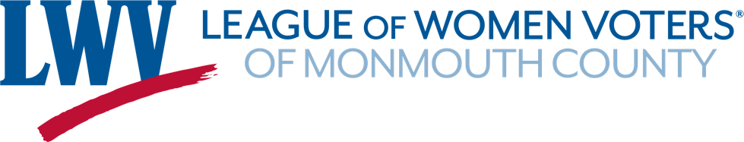

PROCESS OVERVIEW: 2023 Monmouth/Ocean County VOTE411 Initiative
The goal: Cover as many contested Monmouth and Ocean County races as possible.
- Behind the Scenes:
  - LWV Monmouth obtains candidate information from the county clerks and posts candidate lists on www.lwvmonmouth.org.
  - We identify the contested races—that is, races with more candidates than available seats.
  - Ted Dellinger and Anne Torre set up the contested races in the VOTE411 system.
- Volunteer Recruitment and Training: Volunteers learn the ropes and sign up to “champion” races at the training workshop.
- Go Live!
  - Ted and Anne send the official VOTE411 invitation to candidates.
  - Volunteers send introductory emails to candidates in the races they are championing,
  - Volunteers monitor their races and continue to remind (and thank!) their candidates up to November 1st.
  - Ted and Anne will resend official invitations periodically up to November 1st.
- What Do the Candidates Need to Do?
  - Candidates must use their unique individual link to upload information to VOTE411. They receive their links in the official VOTE411 invitation.
  - Candidates can upload a photo, simple biographical and contact information, and their answers to our questions.
  - Our questions (3-4) are intended to give candidates a chance to introduce themselves to voters however they choose to and tell voters what issues are important to them. We have added some more pointed questions this year for each type of race.
- Keep our nonpartisan policy in mind at all times!
  - If you have good emails for ALL candidates and contact them all, you are fine.
  - If you are missing a slate or party, you may not be able to proceed. Talk it over with Anne or Ted. If you have made a good faith effort to reach the missing candidates (mail, phone, etc.), you may be able to proceed.

2023 VOTE411.org “Race Champion” Checklist
Monmouth/Ocean County 2023 General Election Cycle
Race Champions “adopt” one or more races. They are responsible for EMAILING candidates, MONITORING candidate participation, and TROUBLESHOOTING issues with candidate participation.
1. | Select the elections you’d like to cover from the list of contested races. Ideally, you will cover all the races in a municipality—municipal (mayor and council) and Board of Education, if applicable.
2. | Find the candidate emails for each of the races you’re covering. Candidate lists are posted on www.lwvmonmouth.org and will be emailed to you following the volunteer workshop. Most candidate emails are provided on the lists.  If candidate emails are not listed, or candidates are sharing a campaign email, seek to obtain an individual email. Try calling (if you can find a phone number), writing (most mailing addresses are listed), emailing a running mate, Googling the candidate, or asking Anne for help at annetorrebeebe@gmail.com. If candidates are incumbents, you can usually find an email on the municipal or BOE site.
3. | Send the introductory email to the candidates in the races you have adopted. We are ready behind the scenes, so you can start NOW.  - Send one email alert for each race (Mayor, Council, Board of Ed, etc.).  - Include all candidates in the race in the “To” line so the candidates see they are all receiving the same information at the same time.  - We are providing sample text for your email. The email templates are posted on www.lwvmonmouth.org in the VOTE411 Toolkit and will be emailed to you following the volunteer workshop.  - Use League of Women Voters Invitation to VOTE411 as the subject line.  - Keep an email folder of all your correspondence with candidates in case questions arise.  - You no longer need to copy Ted and Anne when you email candidates.  - You must have a unique email for each candidate.
4. | Once you have alerted your candidates, monitor the VOTE411 website for their responses.  - Go the www.vote411.org and enter a street address for your race. Use a candidate address! Click through to the race and you will see which candidates have responded.  - Send a thank you email to candidates who have posted their information (Email template provided.)  - Send a reminder to candidates who have not responded. Again, several templates are provided.  - Continue to monitor and send follow-up email, as needed, to encourage participation up to November 1st.  - Candidates may need help accessing the site and uploading their responses. Help them if you can or put Ted in touch.
5. | Want to do more? Help spread the word about VOTE411. Here are some suggestions:  - Promote VOTE411 to your social networks.  - Arrange for VOTE411 to be advertised on municipal outdoor signs for the races you are championing.  - Attend a public meeting of the Board of Ed or municipal governing body to give a short public statement explaining VOTE411.

